Average rate of change measures how much the function changed, on average, over a given interval. You can think of the average rate of change as the slope of a line joining two points on the function.

The **average rate of change** describes how an output quantity changes relative to the change in the input quantity. To find the average rate of change of a function, $f$, on the interval $[x_{1},x_{2}]$, we use

Example: If we look at the following graph, we can see that the graph does not always increase at the same rate.

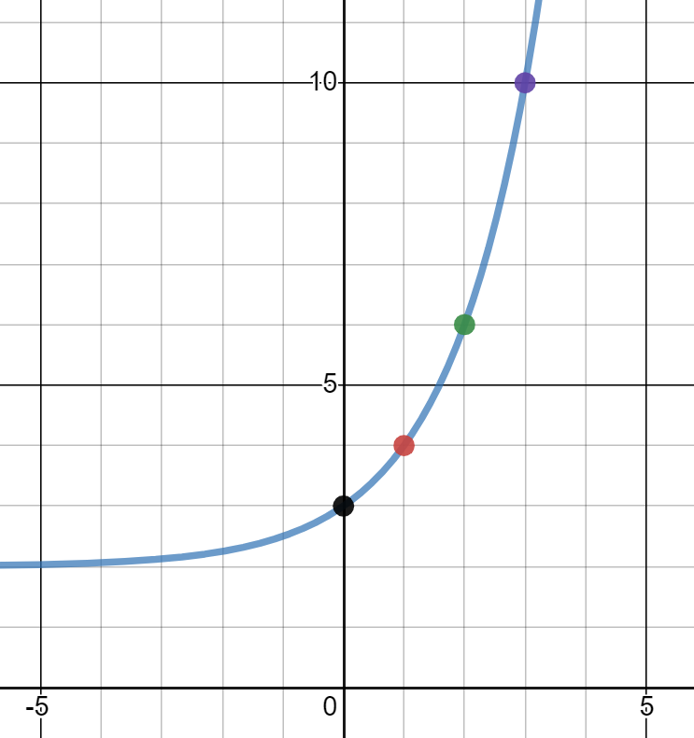

1. What is the average rate of change of the function on the interval [0, 2]?
2. What is the average rate of change of the function on the interval [2, 3]?

Example: Find the average rate of change of $g\left(x\right)=3x^{2}+4$ on the interval [2, 6].

Example: The number of bacteria in a culture increases rapidly. The table below gives the number $N(t)$ of bacteria at a few times *t* (in hours) after the moment when *N* = 1000.

1. Find the average rate of change for the number of bacteria from 3.4 hours to 6.8 hours.
2. Find the average rate of change for the number of bacteria from 6.8 hours to 13.6 hours.